Product Operation Manual

1. Product Summary

1.1 Product Features : Mode 2. Intelligent Portable Charger
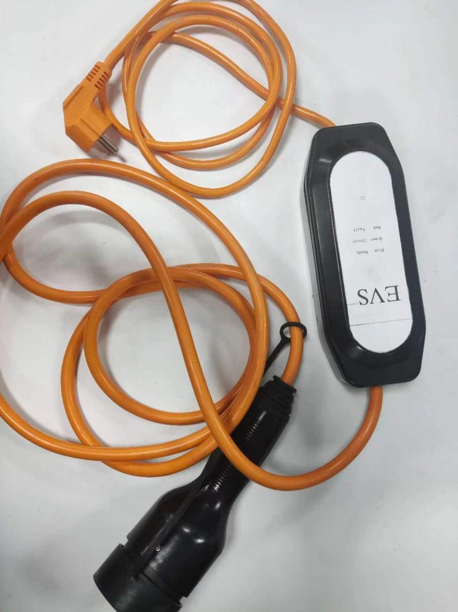

1.2 Product Status Information
No. | Functional Status | Indicator Light
1 | Standby / Fully charged | Blue light is on
2 | In charging | Green light is on
3 | Output overflow | Red light flashes once
4 | The voltage is too high | Red light flashes twice
5 | The voltage is too low | Red light flashes 3 times
6 | Abnormal temperature | Red light flashes 4 times
7 | Ground fault | Red light flashes 6 times

1.3 Conditions of Use
1.3.1 Environmental Conditions
(1) Working environment temperature: -30℃ ~ + 50℃.
(2) Relative humidity: The daily average relative humidity shall be no more than 95%, and the monthly average relative humidity shall be no more than 90%.
(3) Atmospheric pressure: 80kPa ~ 110kPa (at an altitude of 2,000m and below).
(4) When it is used in special areas, it shall be specified when ordering according to local environmental conditions.
1.3.2 Power Requirements:
(1) Rated input voltage: single-phase AC 220V.
(2) Rated output current: single circuit rated current is 13A.
(3) Allowable voltage fluctuation range: 220V ± 20%.
(4) Frequency: 50/60Hz.

1.4 Product Features
High performance ARM chip is adopted, with humanized design, simple and convenient operation. It is equipped with complete protection functions, such as AC over-voltage/under-voltage protection, AC leakage protection, AC output over-voltage/undervoltage protection, output current limiting/over-current protection, over temperature protection, etc. The box body is molded by injection molding at once, which the design is elegant and the quality is durable.

- Application Standards
Products meet the IEC 61851-1-2010 standard and IEC 62752-2018
standard.
One end of the product is the power supply plug ,meet the IEC 60884-1-2011 standard.
The other end of the product is the AC vehicle plug ,meet the IEC 62196-2-2016 standard.

3. Instructions For Use

3.1. Please check before use
(1) Ensure the product is not scratch, rust, rupture or has other abnormal conditions.
(2) Ensure that there is no foreign matter in the power supply plug and socket, as well as the vehicle plug and socket.
(3) Ensure that the leakage circuit breaker is in the closed position.
(4) Do not charge if the surface of the socket is damaged, broken, or the connection is too loose.
(5) When the plug is wet, please clean the plug with a dry and clean cloth.

3.2. How to start the charging process
(1) Open the power distribution box panel.
(2) Put the supply plug firmly into the supply socket of the charger.
(3) Open the vehicle socket cover, and then plug the charging plug into the socket of the vehicle end.
(4) The green indicator light of the charger is on and the charging begins.

3.3. How to stop the charging
(1) When you need to stop charging, if the green indicator of the charger is still on, please press the unlock button on the head of the charging gun, and the green indicator of the charger is off before stop the charging.
(2) Pull the power supply plug out of the power supply socket of the power distribution box.
(3) Pull out the charging plug from the socket of the vehicle end and then close the vehicle socket cover.
(4) Close the power distribution box panel.

4. Packaging、Transportation and Storage

4.1 Packaging
The charging box and accessories are packed in cartons. The box has a plastic bag suit and foam support around it.

4.2 Transportation
Products should not have violent vibration, impact and inversion in transportation.

4.3 Storage
The product shall not be used immediately after purchase. When short-term or long-term storage is needed, the equipment should be stored in a dry and well-ventilated indoor place to avoid high temperature, humidity, dust and metal powder environment.

5. Packaging List
No. | Item Name | Quantity
1 | Product specification | 1
2 | Portable charger | 1
3 | Factory inspection qualification certificate | 1
4 | Factory inspection report | 1
6. Important tips

Warning
1. Non-professional personnel are strictly prohibited to refit, dismantle or repair the charging equipment.
2. Do not use the extra wire or adapter.
3. Immediately stop using the device when charging fails or there is abnormal.
4. Never contact plugs with wet hands.
5. Never touch the charging plug pin and the charging socket jack of the electric vehicle.
6. Must use the device at the rated voltage.
7. It is strictly prohibited to use the equipment in the case of softening, charging gun cable wear, insulation rupture or any other damage.
8. It is strictly prohibited to use the equipment when the charging port of the electric vehicle is disconnected, cracked, opened, or has any damage to the surface.
9. Do not let the child touch or use the device. Do not let the child approach when using it.

Ground Description
- The equipment must be well grounded. If the equipment fails or is damaged, the grounding wire has provided the minimum impedance for circuit discharge to reduce the risk of electric shock.
- The equipment is equipped with a grounding wire connecting the equipment grounding point and the three-phase plug grounding point. The plug must be compatible with a properly installed and grounded power socket.
- If the grounding wire of the equipment is wrongly connected, there will be a danger of electric shock. If you can't confirm whether the grounding of the equipment is good, please contact the relevant professional for testing.
- It is forbidden to replace the original plug of the equipment. If the plug does not match the socket, ask a professional to install a suitable socket.

Mobile and storage
1. It is forbidden to fall.
2. It is strictly forbidden to move the equipment by pulling the cable directly. Please handle the device with care.
3. Please store the decive in a cool place.

Preventive Measurement
1. Do not immerse the AC charging connection device in the water.
2. Never allow the external objects to enter the end of the charging connection port and plug.
3. Do not step on the charging cable, pull the cable, or bend or tie the cable.
4. It is strictly prohibited to use the device in lightning and lightning weather.
5. It is strictly prohibited to drop the charger or press the weight on its surface.
6. It is strictly prohibited to place the equipment near the objects that will produce high temperature when charging.

7. Safety Statement of Product Use
All the AC charging equipment for electric vehicles produced by the company has been inspected and tested before leaving the factory, and consumers can safely use them during the service period of the products.

Safety Warning
7.1 Please read the product manual carefully before use and follow the steps in the use manual.
7.2 The product will have normal slight heating during use.
7.3 Please do not disassemble the product. Improper disassembly may lead to product damage, leakage, waterproof function failure and other phenomena.
7.4 If you have any other questions, please call +86-400-6698-365.

